(YOUR LOGO HERE)

HELP SUPPORT (YOUR ORGANIZATION) BY PURCHASING FRESH ROASTED COFFEE!

ANY 1 POUND BAG OF FRESHLY ROASTED COFFEE OF YOUR CHOICE JUST $15

SINGLE ORIGIN DIRECT TRADE  GUATEMALAN  HOUSE BLEND | DARK ROAST, HEAVY BODIED, SMOKY CARAMEL  FRENCH ROAST | Landgrove coffee  FUNDRAISING  MEDIUM ROAST, FULL FLAVORED VERSATILE  DECAF

Order online at www.landgrovecoffee.com/shop-fundraising
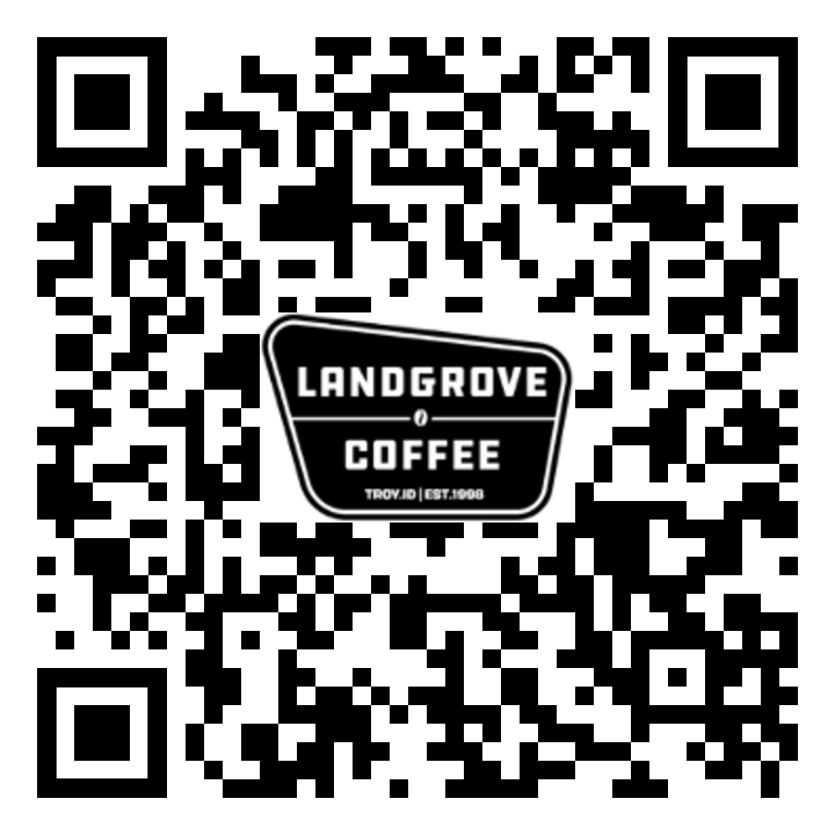

(YOUR ORGANIZATION HERE)
Thanks you for your support!
Name:___________________

Name/Address/Phone# | Medium Ground | Medium  Whole | Dark  Ground | Dark  Whole | Decaf  Ground | Decaf  Whole | Online  Delivery | Check Amount | Total Cash:
Totals:

Name/Address/Phone# | Medium Roast Ground | Medium Roast  Whole | Dark Roast  Ground | Dark Roast  Whole | Decaf  Ground | Decaf  Whole | Total Bags | Total Checks: | Total Cash:
Totals:

